**DIABETES PREDICTION**

**AIM:**

To Predict whether the person is Diabetic or not.

**Diabetes:**

Diabetes is a health condition that affects how your body turns food into energy. Most of the food you eat is broken down into sugar (also called glucose) and released into your bloodstream. When your blood sugar goes up, it signals your pancreas to release insulin.

Without ongoing, careful management, diabetes can lead to a buildup of sugars in the blood, which can increase the risk of dangerous complications, including stroke and heart disease.

**DATASET:**

In this project i used [Pima Indians Diabetes Database](https://www.kaggle.com/gopalj/diabetes-prediction-using-python/data) from [Kaggle](https://www.kaggle.com/). This dataset is originally from the National Institute of Diabetes and Digestive and Kidney Diseases.

<file:///C:\Users\Shantanu%20Mishra\Downloads\diabetes.csv>

Next, I had Cleaned up the dataset which is the important part of data science. Missing data can lead to wrong statistics during modeling and predictions.

I observed that there is no missing values in dataset however the features like Glucose, Blood Pressure, Insulin, Skin Thickness has 0 values which is not possible. We have to replace 0 values with either mean or median values of specific column.

Parameters taken as INPUT:

1. Pregnancies

2. Glucose

3. Blood Pressure

4. Skin Thickness

5. Insulin

6. BMI

7. Diabetes Pedigree Function

OUTPUT Given:

0: Not Diabetic

1: Diabetic

**Libraries Used:**

1. Numpy
2. Pandas
3. StandardScaler from sklearn.preprocessing
4. train_test_split from sklearn.model_selection
5. svm from sklearn
6. accuracy_score from sklearn.metrics

**MODEL USED:**

I tried different models and compare the accuracy for each. Then, I performed Hyperparameter Tuning on Models that has high accuracy. I have used **Support Vector Machine Model** for the prediction of Diabetes.

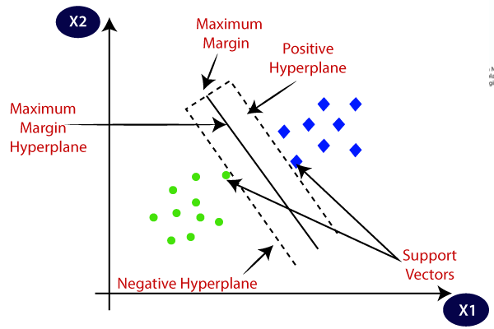

In the Support Vector Machine Model, as we train the Machine Learning Model with the Data the Support Vector Machine Model after training the data it identifies a hyperplane and divide it into Positive and Negative hyperplane.

**CONCLUSION:**

1. Diabetes is one of the ricks during Pregnancy. It has to be treated to avoid complications.
2. BMI index can help to avoid complications of diabetes a way before.
3. Diabetes start showing in age of 35 – 40 and increase with person age.